**Exercise 1: Configuring a Basic Spring Application**

**Scenario: Your company is developing a web application for managing a library. You need to use the Spring Framework to handle the backend operations.**

Code:

applicationContext.xml

<beans xmlns="http://www.springframework.org/schema/beans"

xmlns:xsi="http://www.w3.org/2001/XMLSchema-instance"

xsi:schemaLocation="

http://www.springframework.org/schema/beans

http://www.springframework.org/schema/beans/spring-beans.xsd">

<!-- Repository Bean -->

<bean id="bookRepository" class="com.library.repository.BookRepository"/>

<!-- Service Bean with DI -->

<bean id="bookService" class="com.library.service.BookService">

<property name="bookRepository" ref="bookRepository"/>

</bean>

</beans>

BookRepository.java

**package** com.library.repository;

**public** **class** BookRepository {

**public** **void** saveBook(String bookName) {

System.***out***.println("Book \"" + bookName + "\" saved to database.");

}

}

BookService.java

**package** com.library.service;

**import** com.library.repository.BookRepository;

**public** **class** BookService {

**private** BookRepository bookRepository;

**public** **void** setBookRepository(BookRepository bookRepository) {

**this**.bookRepository = bookRepository;

}

**public** **void** addBook(String bookName) {

System.***out***.println("Adding book: " + bookName);

bookRepository.saveBook(bookName);

}

}

LibraryManagementApplication.java

**package** com.library;

**import** com.library.service.BookService;

**import** org.springframework.context.ApplicationContext;

**import** org.springframework.context.support.ClassPathXmlApplicationContext;

**public** **class** LibraryManagementApplication {

**public** **static** **void** main(String[] args) {

ApplicationContext context = **new** ClassPathXmlApplicationContext("applicationContext.xml");

BookService bookService = (BookService) context.getBean("bookService");

bookService.addBook("Clean Code");

}

}

Output:

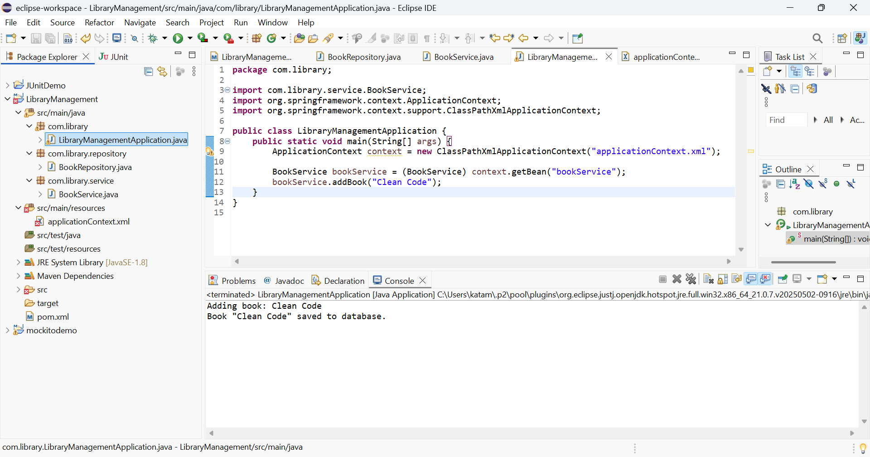

**Exercise 2: Implementing Dependency Injection**

**Scenario: In the library management application, you need to manage the dependencies between the BookService and BookRepository classes using Spring's IoC and DI.**

Code:

applicationContext.xml

<beans xmlns="http://www.springframework.org/schema/beans"

xmlns:xsi="http://www.w3.org/2001/XMLSchema-instance"

xsi:schemaLocation="

http://www.springframework.org/schema/beans

http://www.springframework.org/schema/beans/spring-beans.xsd">

<!-- Repository Bean -->

<bean id="bookRepository" class="com.library.repository.BookRepository"/>

<!-- Service Bean with DI -->

<bean id="bookService" class="com.library.service.BookService">

<property name="bookRepository" ref="bookRepository"/>

</bean>

</beans>

BookRepository.java

**package** com.library.repository;

**public** **class** BookRepository {

**public** **void** saveBook(String bookName) {

System.***out***.println("Book \"" + bookName + "\" saved to database.");

}

}

BookService.java

**package** com.library.service;

**import** com.library.repository.BookRepository;

**public** **class** BookService {

**private** BookRepository bookRepository;

// Setter for Dependency Injection

**public** **void** setBookRepository(BookRepository bookRepository) {

**this**.bookRepository = bookRepository;

}

**public** **void** addBook(String bookName) {

System.***out***.println("Adding book: " + bookName);

bookRepository.saveBook(bookName);

}

}

LibraryManagementApplication.java

**package** com.library;

**import** com.library.service.BookService;

**import** org.springframework.context.ApplicationContext;

**import** org.springframework.context.support.ClassPathXmlApplicationContext;

**public** **class** LibraryManagementApplication {

**public** **static** **void** main(String[] args) {

// Load the Spring context

ApplicationContext context = **new** ClassPathXmlApplicationContext("applicationContext.xml");

// Get BookService bean

BookService bookService = (BookService) context.getBean("bookService");

// Use the service

bookService.addBook("Clean Code");

}

}

Output:

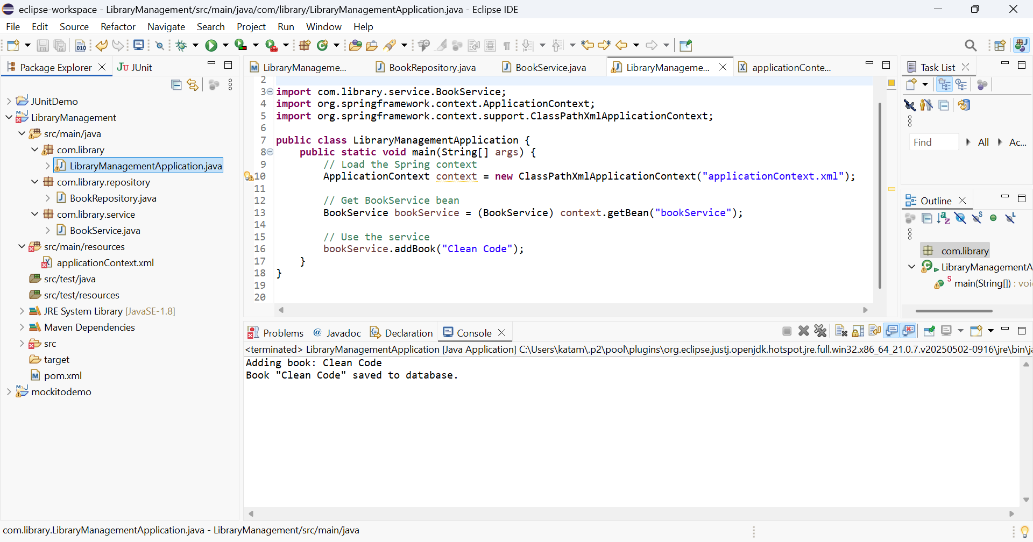

**Exercise 4: Creating and Configuring a Maven Project**

**Scenario: You need to set up a new Maven project for the library management application and add Spring dependencies.**

Code:

pom.xml

<project xmlns="http://maven.apache.org/POM/4.0.0" xmlns:xsi="http://www.w3.org/2001/XMLSchema-instance" xsi:schemaLocation="http://maven.apache.org/POM/4.0.0 https://maven.apache.org/xsd/maven-4.0.0.xsd">

<modelVersion>4.0.0</modelVersion>

<groupId>com.library</groupId>

<artifactId>LibraryManagement</artifactId>

<version>0.0.1-SNAPSHOT</version>

<name>LibraryManagement</name>

<dependencies>

<!-- Spring Core -->

<dependency>

<groupId>org.springframework</groupId>

<artifactId>spring-context</artifactId>

<version>5.3.32</version>

</dependency>

<!-- Spring AOP -->

<dependency>

<groupId>org.springframework</groupId>

<artifactId>spring-aop</artifactId>

<version>5.3.32</version>

</dependency>

<!-- Spring Web MVC -->

<dependency>

<groupId>org.springframework</groupId>

<artifactId>spring-webmvc</artifactId>

<version>5.3.32</version>

</dependency>

</dependencies>

<build>

<plugins>

<plugin>

<groupId>org.apache.maven.plugins</groupId>

<artifactId>maven-compiler-plugin</artifactId>

<version>3.8.1</version>

<configuration>

<source>1.8</source>

<target>1.8</target>

</configuration>

</plugin>

</plugins>

</build>

</project>

output:

